

Usability Study
I2P Client Setup

24th October 2018

A research study by Ura Design
Supported by Open Technology Fund



About

Ura Design

Ura is a digital agency focuses on visual communication solutions tailored for Open Source and Internet Freedom projects. They are dedicated to Usability and Experiences by keeping project’s unique community consensus model in mind.

Ura was founded in 2016 in Albania to cater to the ever-rising demand for Usability and Design services in Open Source Software.

I2P

I2P (The Invisible Internet Project) is an anonymous overlay network - a network within a network.

It protects communication from dragnet surveillance methods and monitoring by third parties such as ISPs.

I2P is used by many people who care about their privacy: activists, oppressed people, and whistleblowers, as well as the average person. No network can be "perfectly anonymous" The continued goal of I2P is to make attacks more and more difficult to mount.

Table of Contents

Introduction | 3
Methodology | 4
Pre-test Questions/Demographics | 7
Follow-up Questions | 8
Heatmap | 9
Findings & Recommendations | 11
Conclusions | 21
Exit Questions / User Impressions | 22
Acknowledgments | 23
Licensing | 24

Introduction

Usability testing is a method for improving and measuring the ease-of-use of a software. Usability Evaluation focuses on how well users can learn and use a program to achieve their goals. Typically, the test is conducted with a group of potential users in a usability lab. In the lab, users are asked to complete a series of routine tasks. Sessions are then analyzed to identify potential areas for improvement of the program.

I2P is an advanced piece of software with an extensive range of features to offer, it is broadly used by many people who care about their privacy: activists, oppressed people, journalists, and whistleblowers, as well as “average” users. Improving the Usability of I2P has the benefit of reducing the users frustration while navigating through the software.
One process that all these users must go through in order to use I2P is installing and configuring it, so that’s what we have focused on in this round of testing.

In this paper, we aim to:
- Describe every potential usability issue of the installation / configuration noticed during the testing sessions
- Describe participants’ feedback
- Show satisfactions ratings
- Show task completion rates
- Show the ease or difficulty of completion ratings
- Provide constructive feedback
- Describe any errors found during testing
- Provide design recommendations for improvement

Ideally, our findings and recommendations contained within this report will help to improve the existing user experience of the setup process and increase the level of user confidence while using I2P.

Methodology

The Usability evaluation of I2P was conducted by the Ura Design team at the Open Labs Hackerspace (Tirana, Albania) in July and August 2018. Although the testing environment was a hackerspace, participants came from a variety of backgrounds.

We conducted 1:1 traditional Usability Testing. The test itself took place in a quiet space that Open Labs offered together with stable Wi-Fi. Participants were equipped with laptops and instructions including the tasks they needed to perform during the test. In traditional usability testing, typically only one participant at a time can enter the room and take the test.

The test administrator was sitting next to the participant observing and taking notes. This type of testing fit perfectly in this case because it allowed us to see closely where the issues are and notice the users’ frustration even if they don’t express it verbally.

All the participants were volunteers from different backgrounds who offered their time and effort to help improve the Usability of I2P. At the end of the session, they were offered stickers as a thank you token for their participation.

During the Usability evaluation, ten participants, matching the user profiles, were asked to spend one hour with this test. During this hour, participants:

- Completed a user background questionnaire
- Answered questions about initial site and program impressions
- Performed real-world tasks on the site while thinking aloud
- Answered questions about their overall satisfaction

The session captured each participant’s navigational choices, task completion rates, comments, overall satisfaction ratings, questions, and feedback.

In agreement with the I2P community, participants were allowed to use the documentation and any browser supported. Since users usually look for help on the documentation when installing a new software, we saw this as an opportunity to simultaneously test the documentation’s usability along with the program itself.

We also encouraged testers to use different browsers to test with, so we could cover as many use case scenarios as possible. Of course, they were not pressured to use any specific browser, it was up to them to decide what they felt more comfortable using.
We also wanted to cover a variety of operating systems and compare them; the installation process is a little different on each operating system and that led us to interesting results. Participants were allowed to use any Linux distribution and Windows.

URL | https://geti2p.net/en/
Hardware | Lenovo Thinkpad T430  Lenovo Thinkpad - X201  Lenovo ThinkPad X1 Carbon (2016)  Asus X556UJ
Operating system | Fedora 28 - 2 testers  Windows 10 - 6 testers  Ubuntu 18.04 - 1 tester  Debian - 1 tester
Browser used | Chrome - 4 testers  Firefox - 5 testers  Edge - 1 tester

We created six (6) tasks in total.

On the left side of the table are the tasks that were printed before the test and handed out to each participant.

On the right side, you can find the purpose of each task, which only serves as clarification for the reader of this document.

Task | Purpose
1. You decided to use I2P regularly, so the first step would be downloading it from: https://geti2p.net/en/ | How intuitive is it for users to find the link/button on the site?
2. Continue the process of installation without making any changes to the default Configuration. | After downloading, will users get confused with the process of installation?
3. Change your bandwidth settings. | Can participants find out how to change the bandwidth settings, where do they expect to find that menu?
4. Setup your browser to use the I2P proxy to reach eepsites (hidden services). | Can testers figure out how to set up their browsers? Can they find out themselves? If not do they know where to look for help?
5. Please connect to your favorite eepsite (example: http://i2pforum.i2p/) | Do users know how to connect to eepsites?
6. Optional: Point your IRC client to localhost:6668 and say hi to us on #i2p. | Finalize the test with saying hi in #i2p, this task applies only to those who use IRC.

Pre-test Questions / Demographics

For this part, we are focusing on demographics. Hopefully it will create a clear picture of the testing process and will help to “get to know” the users and understand them better.

We had a healthy variety of backgrounds, some of them were students, some work in tech industry and the others in different fields. The majority of testers haven’t used I2P before, which proved to be a convenient aspect for our test setting.

Ten volunteers participated in this usability test, representing a mix of gender and age ranges (mostly age 18-39.)

We’ve had people of different background and technical expertise take the test.

Computer Usage | Users
11 to 25 hrs. wk. | 2
26+ hrs. wk. | 8

Gender | Users
Women | 4
Men | 6

Age | Users
18-25 | 8
26-39 | 2

Audience | Users
Students | 6
Working | 4

The test started with us explaining briefly what usability testing is and why it’s important.

“Hi [Name], thank you for participating in this session of usability testing for I2P. Usability testing is a method for improving and measuring the ease-of-use of a software.

We’ll give you the tasks one at a time. We aren’t “testing” you. The test is all about the software. If you have problems with parts of the test, that’s okay; that’s exactly what we are trying to find.

Don’t feel embarrassed if you have problems doing something and please do not feel pressured by time or anything else. If you can’t figure something out, that is perfectly okay and would still provide us with useful information for the test. If you have any questions about the tasks we will try to answer them, but the answers and feedback should come directly from you as much as possible, so we will avoid anything that would lead you to a specific choice. Also, we’re going to take notes while you’re doing these tasks. It will help us if you talk out loud when you are doing something, so we can take notes.

Example: If you’re looking for a Print button, just say “I’m looking for a Print button” and move the mouse to wherever you are looking on the screen, so we can see where you’re looking.”

Follow-up Questions

We extended the testing time and asked questions about specific tasks that
the tester found more difficult to use. Questions like:

- “What were you thinking while completing this task?”

- “Would it be more obvious for you to find this menu placed here?”

- “Where did you expect to find this icon/menu?”

- “How would it be more logical for you to accomplish this task?”

Heat Map

We used a heat-map technique to summarize our usability test results. This method seemed fitting to see how users performed on each task. The heat map clarifies how easy or difficult it was for the participant to accomplish a certain task.

How to read the map:
- Scenario tasks (from the usability test) are arranged in rows.
- Test participants are arranged in columns (P1-10)
- The colored blocks represent each tester’s difficulty with each scenario task.

G Green blocks represent the ability of the participant to accomplish the tasks with little or no difficulty.

Y Yellow blocks indicate the tasks that the tester had significant difficulties in accomplishing.

R Red blocks indicate that testers experienced extreme difficulty or where testers completed the tasks incorrectly.

B Black blocks indicate tasks the tester was unable to complete.

- Gray blocks indicate option tasks the tester skipped and didn’t attempt.

 | P  1 | P  2 | P  3 | P  4 | P  5 | P  6 | P  7 | P  8 | P  9 | P  10
1. Download I2P | G | G | G | G | Y | Y | G | G | G | Y
2. Install I2P | Y | G | R | G | G | G | G | Y | G | G
3. Adjust your bandwidth settings | Y | R | R | R | Y | R | R | Y | R | Y
4. Setup browser to use I2P proxy to reach websites | R | R | R | Y | Y | R | Y | Y | R | R
5. Connect to your favorite website | Y | B | Y | Y | G | B | G | G | B | Y
6. Say hi on #i2p IRC channel | - | - | - | G | - | - | B | - | - | -
We can see that the green and yellow boxes dominate the first two rows of the map which indicates that the tasks performed well in those cases. While red and black are located mostly in the center and end of the map and indicate the tasks that users struggled with.

Task #1, Download I2P, is the task that performed the best. Three out of ten participants needed a little more time to grasp it, but that is totally acceptable.

Task #2, Install I2P, belongs to the tasks that are performed well. Only two participants hesitated during this task.

Task #3, Adjust your bandwidth settings, didn’t perform quite as well as the first tasks. Six participants spent more time tackling them than they were supposed to.

Task #4, Setup browser to use I2P proxy to reach websites, had similar results as the third task. Users spent a considerable amount of time working on it.

Task #5, Connect to your favorite website, is a derivative of the fourth task, so if the user was able to setup the browser to use I2P, they were able to connect to an eepsite.

Task #6, Say hi on #i2p IRC channel, is dominated by gray boxes since this task was optional to begin with. The majority of the testers hadn’t use IRC before, so they just skipped the task.

We will go through each task individually and explain in detail each usability flaw encountered during the testing sessions. Starting from the website usability, how easy it was to figure out how to download I2P, how usable and helpful was the documentation, how difficult was the browser setup process and did it make sense to users, how much time they spent on figuring out the process, and how intuitive was the console. All these are described specifically for each operating system we tested on.

Findings & Recommendations

1. You decided to use I2P regularly, so the first step would be downloading it from: https://geti2p.net/en/

Users started the task by launching whichever browser they preferred to test with. They were not constrained to use any particular browser or operating system because we wanted to see how the installation and the setup process performed in different environments. Participants went for what they use daily, so they felt more comfortable during the sessions and that led to performing better on the test.

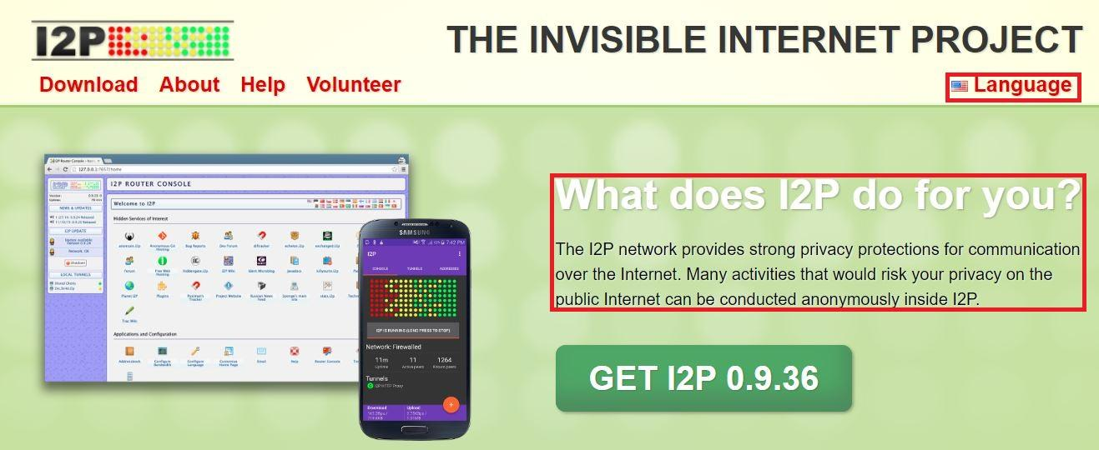

The first impression of the site was satisfying. Users were immediately served with the information they were looking for, without having to navigate through different parts of the site, which is time consuming and causes frustration.

Participants found the Language icon helpful and were pleasantly surprised with the variety of languages offered, although they all ended up using English language since Albanian language was not offered as an option. All participants were fluent in English, so the language didn’t influence the test performance in any way.

The paragraph on the header served as a good introduction to I2P, but we offered additional information to help them better understand the program and its purpose.
Downloading I2P was straightforward. Participants were already familiar with the process. The big green button with the GET I2P description is eye-catching and helps to direct the user when first presented with the site.

On the site, you can find a few options to download I2P and that confused some participants during the sessions. Despite the green button, there is also an option to download it on the navbar and footer (see screenshot below) and they all link to the same download page. Most participants used the button to download I2P—only one participant used the nav bar option—and they all ignored the footer.
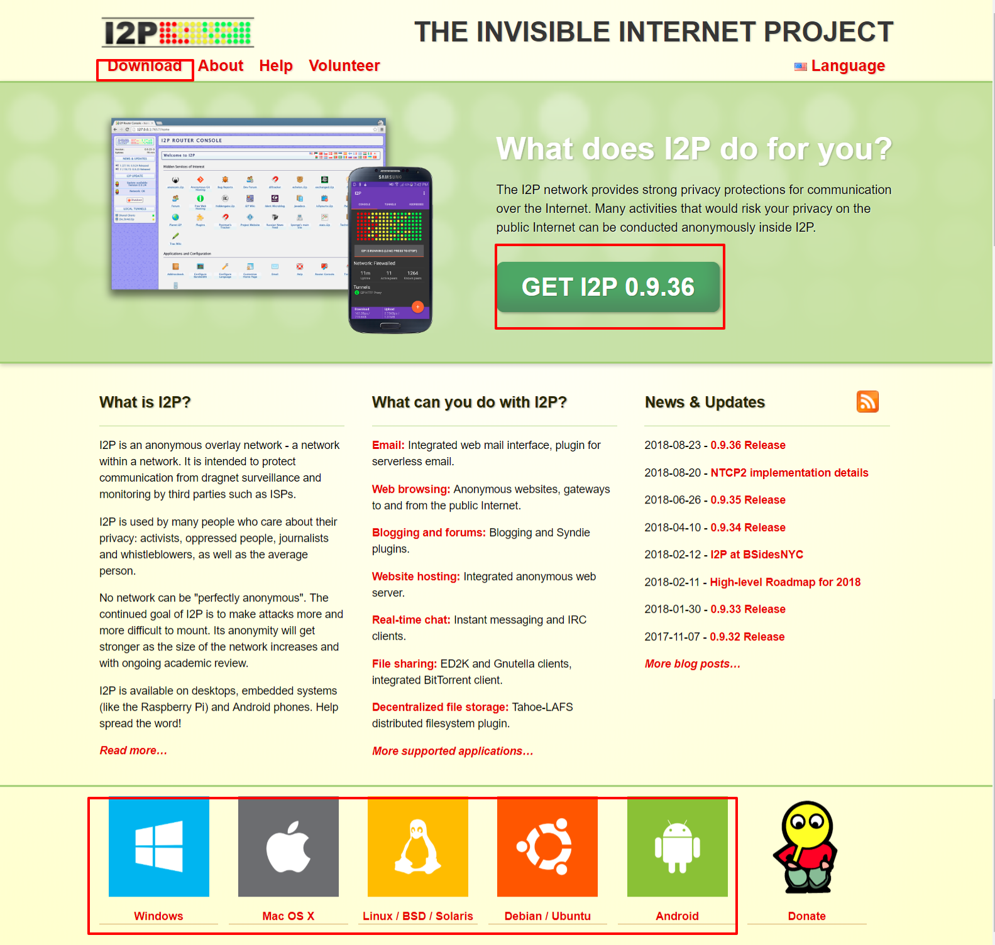

Recommendations:

- Having the same functionality many times on the same page caused confusion to the users and is also an inefficient way to use the site’s space. Removing the download options from the footer would allow space for other important information that the user needs to access quickly.
- A good addition would be replacing the actual footer content with a footer where users can find some quick useful information like a donate icon, a sitemap, a link that directs to a contact page, the language feature and a download link that directs the user to https://geti2p.net/en/download.
- Moving the Language icon from the header (see screenshot above) and placing it on the footer would be a nice change since the language option is important enough to be on the homepage but not as needed from the users to see it right away every time the page is loaded.
- Another recommendation would be to make it possible to click the Get I2P button, automatically recognize the operating system, and download the compatible version of I2P.

After downloading I2P, most of participants didn’t use the Post install information on the page to proceed to using the program. Users choose to explore the options themselves because they found the page to be too cluttered with information, so they just went back to the home page.
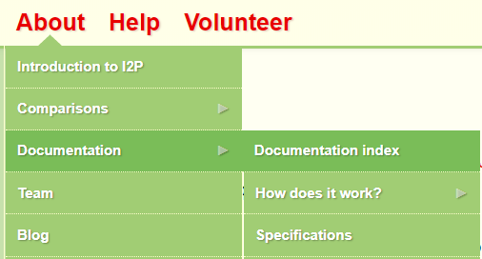

That led to having difficulties bringing up the router console and not knowing what the next step was after installing the software.
Some participants referred to the documentation but had difficulty finding the information they were looking for.

They tried clicking on the documentation index (screenshot above) with the expectation to find a step by step guide on how to setup and use I2P. Instead they were presented with detailed technical information on how I2P is build and how it works.

After that, some participants went back to the Download page and found the post install information but for others this option didn’t make sense because they expected to find there only the files to install I2P. Other participants continued searching on other parts of documentation.
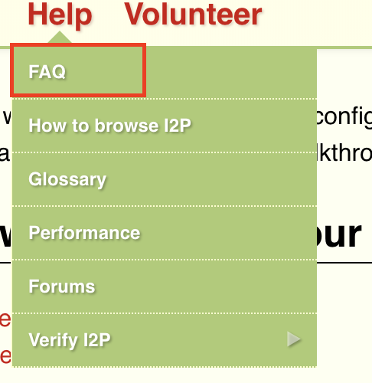

They tried Frequently Asked Questions, but they mostly found general information about I2P, terminology explained, and troubleshooting.

Recommendations:

- Users don’t often find themselves scrolling through a lot of text; they prefer to have information presented in a visual form. In that way, they aren’t required to go through a lot of documentation and finding what they are looking for is less time consuming.
- What would be most helpful would be having a Post install guide that is written in a step by step format, including only the most crucial information. The information is already on the site (https://geti2p.net/en/download), with a little restructuring it would be much easier to read.

2. Continue the process of installation without making any changes to the default Configuration

The participants didn’t encounter any issues during the installation process mainly due to wizard dialogs help on Windows.
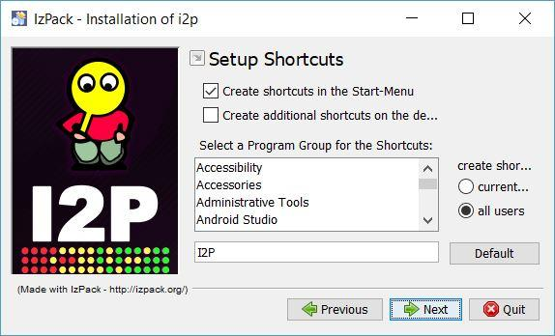

After installation, the user waited and expected a shortcut of the application to appear on the desktop. Since the “Create additional shortcuts on desktop” was disabled by default, users couldn’t find a shortcut on the desktop so they weren’t sure how to start I2P.

After some waiting they thought something went wrong with the installation so they searched on Windows search bar the keyword “I2P” and two options showed up: Start I2P (no window) and Start I2P (restartable).
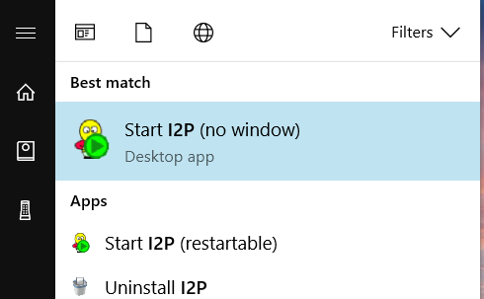
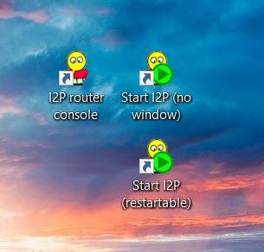
They weren’t sure which one to click and what was the difference between these versions so they just tried one of them hoping to guess correctly.
The I2P icon located on the taskbar (Windows 10) wasn’t noticeable enough. The icon only shows up when the user clicks the arrow that reveals other apps on taskbar. Only a few participants were able to see it and launch the browser using this menu.
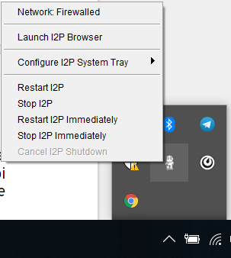
The icon activates the menu only on right click and that was confusing, users thought the icon had no function. It took a couple of tries to realize that the menu activates on right click. The options on the menu were also confusing especially the last options, participants asked questions like: What is the difference between “Restart I2P” and “Restart I2P Immediately”? What is the difference between “Stop I2P” and “Stop I2P Immediately”?

Also, the states of Network were different on two different Windows machines. One of them being Network: Firewalled and the other Network: Testing. Testers didn’t understand if that was an actual option of the menu that you can click on or it was just an indicator that shows the network status.

Configure I2P System Tray showed only one option: Disable. Participants didn’t understand its purpose and they expected to find more options to be listed besides Disable, it should contain more options to configure.
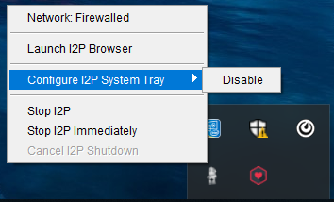

The I2P shortcuts opened the console on different browsers. One of the machines that we tested with had the default browser set to Chrome, but the console opened automatically on Internet Explorer (Edge).

Start I2P (restartable) opened the terminal and the participant seemed confused; he thought that the only way to use I2P was through the command line.

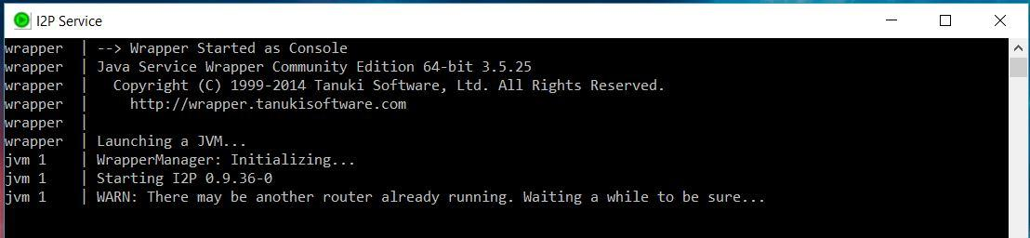

Users who run the test on Linux machines didn’t have any problem with this task since they already knew how to start the program the same way they started other programs they had installed previously. Only one participant had difficulties because they downloaded the wrong file, but they suddenly realized their mistake and quickly fixed it.

Recommendations:

- Having the Create additional shortcuts on desktop option checked by default would avoid the confusion that users had during the testing sessions trying to find out what happens after the installation and how to start the program. Also, include on the documentation an explanation of what the three options (Start I2P (no window), Start I2P (restartable), I2P (router console) do, so the user can easily decide what to click on.
- The gray I2P icon on Windows taskbar wasn’t easily recognizable by users. Having it replaced with another icon that resembles the shortcuts icons on the desktop would make more sense to users because they are already familiar with the I2P logo and colors.
- The right click menu seems too cluttered. In this case, we should keep on the menu only options that are most necessary and give them names and descriptions that are easy to understand. If the Network option is just an indicator, then it would be a good idea to remove it entirely from the menu, to avoid causing the users confusion.

- The Launch I2P Browser option gives an impression that I2P is a browser itself and is not going to open on a pre-installed browser like Firefox, Chrome, etc. A better re-phrase for this option would be Launch I2P on Browser or Launch I2P Router Console.

3. Change your bandwidth settings

The Console icons seemed to be quite understandable. Users figured out how to configure the bandwidth with the help of icons on the console. The UI is intuitive in this case, but the problem is that testers didn’t understand what it meant to adjust the bandwidth, what was the right way to do it, or how it impacts the program.

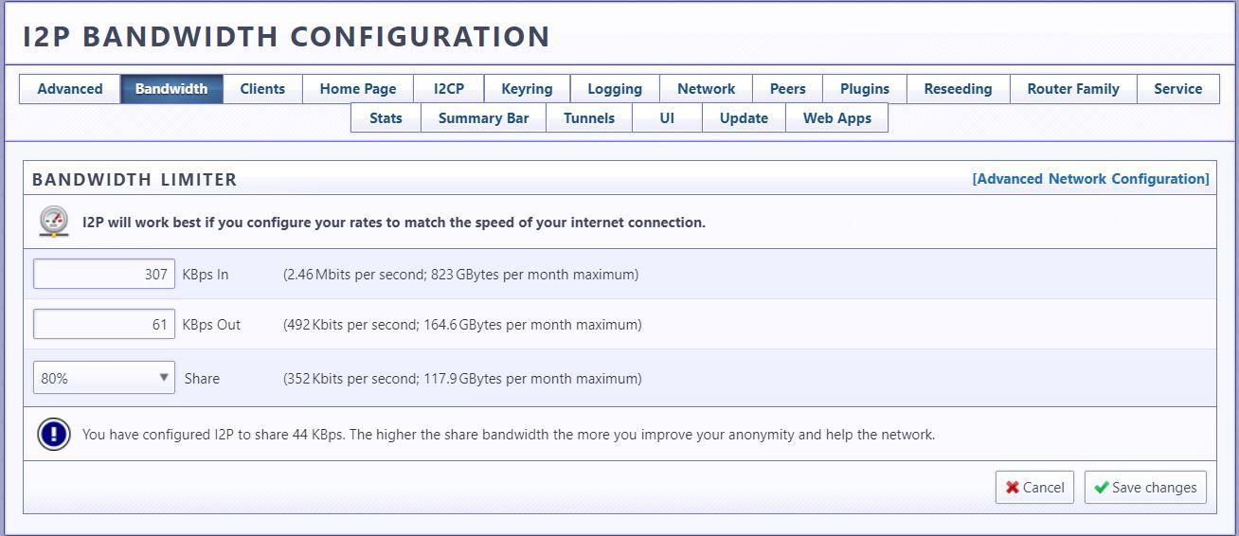
Recommendations:

- Include as much information as possible to clarify to the user what adjusting the bandwidth means in text format that they can read and easily understand.
- Include information on how they can check their actual bandwidth before adjusting it.

4. Setup your browser to use the I2P proxy to reach eepsites (hidden services)

Setting up the browser to use I2P was the hardest task to tackle for every participant. As mentioned previously, users at first expected I2P to be a desktop application or a browser they could search on. At this point, they realized that they needed to use a browser to set it up in order to reach eepsites.
Users mostly used Firefox, but we had some cases that tested on Chrome and Edge too. Testers again had difficulty finding the documentation on how to configure the browser.
They went to the Post install work page they used in the beginning (https://geti2p.net/en/download) and expected to find a section that explained browser configuration. They couldn’t find it there so they started looking on different parts of the documentation and found it on the website (https://geti2p.net/en/about/browser-config).

The documentation in this case was easily understandable for users; they found the screenshots to be very helpful since they gave them a visual form of what the process should look like, so they didn’t need to spend too much time reading. Most users looked on I2P Router Console to find the browser configuration guide. They clicked on I2P Technical Docs option but that didn’t open since it’s an (.i2p) page.

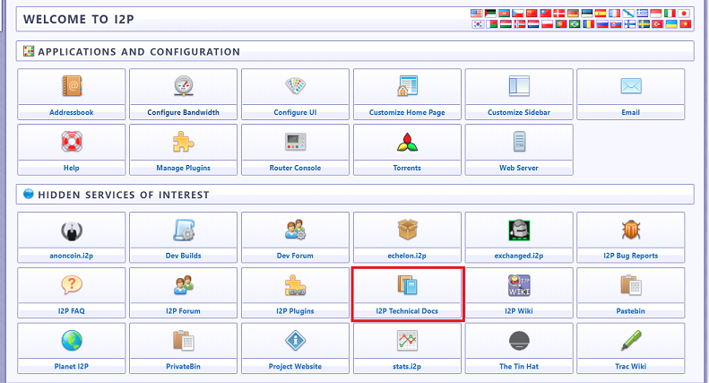

Recommendations:

- How to configure browser or Browser Configuration instead of “How to browse I2P” would make more sense to users in this case (screenshot below).
- Also, the documentation for browser configuration should be merged with the Post install work documentation, since they go hand in hand. This way users can find all the steps they need to perform after installation on one place.
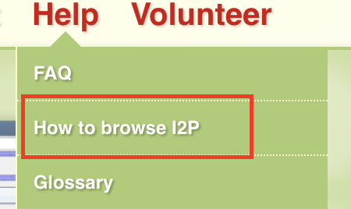

5. Please connect to your favorite eepsite (example: http://i2pforum.i2p/ )

No participant had previous knowledge of what an eepsite is. Some of them searched the documentation to find what out what it meant. It took them some time to find it.

They took a look at “Introduction to I2P” on the navbar but couldn’t find it. Then, they explored some other options. And finally, they found more info on eepsites on the FAQ page. A few participants searched on Google to find the definition of an eepsite while others asked directly for help.

After successfully finishing the previous tasks, this one was pretty straightforward. Users had already downloaded and installed I2P, and they had setup the browser and made the correct configurations, so this task served more as a final test. If they did the other tasks correctly, then the eepsite showed up on the browser. If not, the tester went back to previous steps to see what they did wrong.

Three out of ten testers weren’t able to connect to an eepsite on the first try. They looked back to see what went wrong. On the second try all participants were able to connect.

6. Optional: Point your IRC client to localhost:6668 and say hi to us on #i2p.

This task was optional and dedicated to the participants who had used IRC before. Only 1 out of 10 participants completed this task. Another tester tried to figure out how to do it even though he had never used IRC before but only heard of it during talks he participated previously. He found a how-to guide on the documentation (https://geti2p.net/en/faq#irc) but still couldn’t properly set it up and use it.

Conclusions

These considerations aim to improve the usability of I2P using the existing features and UI. Generally speaking, I2P would benefit from documentation housekeeping and UI improvements, especially in the router console. There are a variety of low hanging fruits which can drastically improve the overall experience and address most considerations in this study.

Users are not familiar with Technical Concepts
When downloading and setting up I2P all users no matter their technical background should be able to perform these tasks in order to use the program. A user should not be expected to be familiar with terms like eepsites, router console, and should not need to know the terms in order to setup I2P.

Information Architecture of the Website
While having a lot of information is a great way to help the user get to know the program and how to use it, we should be careful with how it is presented to the user. Too much information at once can scare the user away. For example, the site has a bunch of submenus which is considered an overload of information (see screenshot below). Having the submenus arranged in a way that the user can find it only when they need them would help in this case.

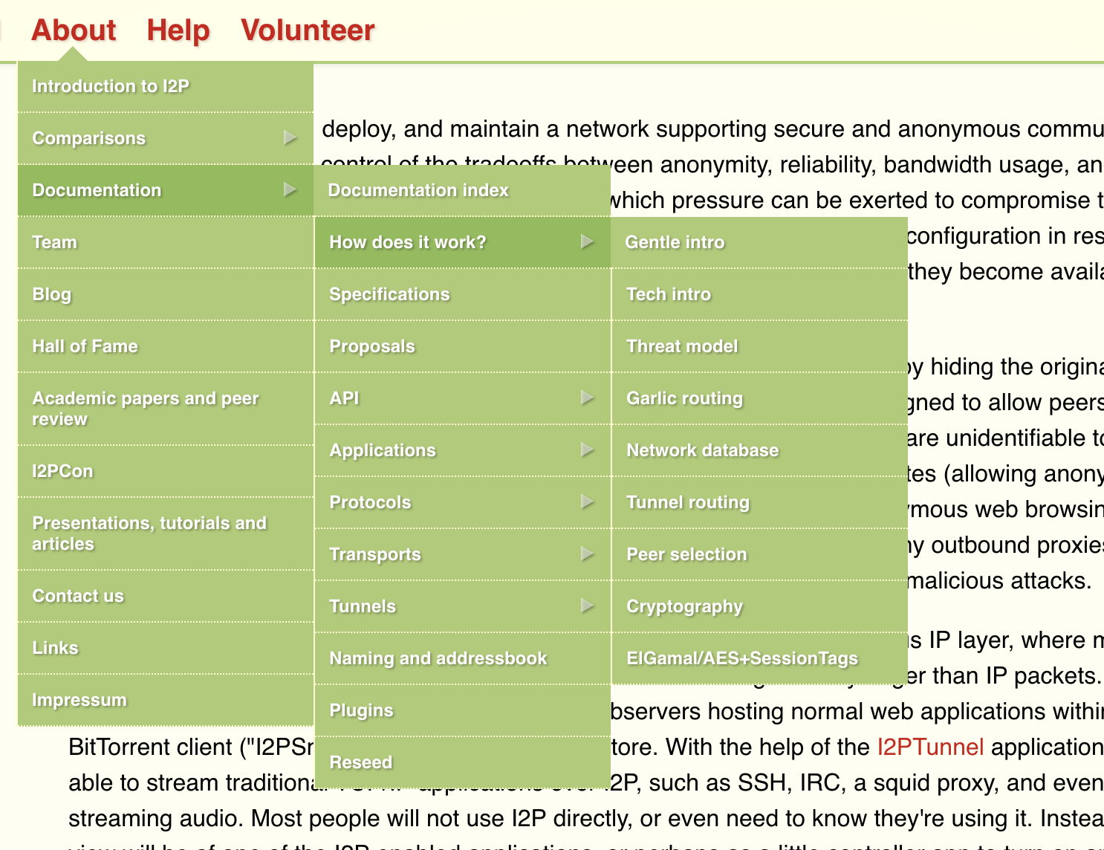

Exit Questions / User Impressions

At the end of each session, we asked participants five questions, here are some keywords and answers summed up:

- What is your overall impression to I2P expressed in keywords?
Interesting, confusing, useful, crowded, complicated, etc.

- Do you feel this site documentation is helpful?
Yes, it is very helpful. It contains a lot of information about the software and you can find most of the problems you encounter during/after installation described there, but the information is hard to find at first.

- What did you like best about I2P?
Reaching eepsites and exploring the hidden services.

- Is there anything that you feel is missing on the site/program functionality or feature wise?
It was good overall. Needs improvements on the design and less unfamiliar terms.

- Would you use I2P again?
Yes I would, if I need to use it.

Acknowledgments

Ura Team Members who worked on this study:

Renata Gegaj Usability Researcher
Anxhelo Lushka Frontend Designer
Elio Qoshi Creative Lead

This research has been made possible by Open Tech Fund, which kindly sponsored this work.

This study has been conducted in Tirana, Albania and Prishtina, Kosova.

Licensing

Some rights reserved © 2018 Ura Design

This work is licensed under a Creative Commons Attribution ShareAlike 4.0 International License.

You can find the full license text here.

First published on 24th October 2018.

